T **ANALYZING FUTURE TRENDS IN WORLD POPULATION**

## Submitted by

**N.Rajeswari (192224262),**

**M.Gowripriya(192224223).**

## Guided by

V.Saranya

Junior Research Fellow

Department of Neural Networks

Department of Computer Science and Engineering,

Saveetha School of Engineering, SIMATS Thandalam, Chennai

March – 2024

# PROBLEM STATEMENT

The problem statement about world population typically revolves around the challenges posed by population growth, distribution, and demographic changes. These challenges include:

**Overpopulation:** Many regions, particularly developing countries, face the issue of overpopulation, leading to strain on resources such as food, water, and energy, as well as environmental degradation and social problems. Uneven Population Distribution: Population is not evenly distributed across the globe. Some areas are densely populated, while others are sparsely inhabited. This non-uniform distribution can lead to disparities in resource allocation, economic development, and access to services like healthcare and education.

**Population Growth:** While fertility rates have declined globally, the world's population continues to grow, albeit at different rates in different regions. Sustained population growth can exacerbate issues related to food security, urbanization, and climate change.

**Migration and Urbanization:** Rapid urbanization and migration from rural to urban areas pose challenges such as strain on infrastructure, housing shortages, and social integration issues.

**Resource Depletion and Environmental Impact:** The growing population puts pressure on natural resources such as water, land, and forests, leading to depletion and environmental degradation. This can result in biodiversity loss, climate change, and other ecological crises.

To solve these problems, broad approaches are needed, including family planning events, equitable resource distribution, equitable access to healthcare and education, and steps that reduce the adverse ecological consequences of human activities.

**DATASET ANALYSIS**

The current US Census Bureau world population estimate in June 2019 shows that the current global population is 7,577,130,400 people on earth, which far exceeds the world population of 7.2 billion from 2015. Our own estimate based on UN data shows the world's population surpassing 7.7 billion.

China is the most populous country in the world with a population exceeding 1.4 billion. It is one of just two countries with a population of more than 1 billion, with India being the second. As of 2018, India has a population of over 1.355 billion people, and its population growth is expected to continue through at least 2050. By the year 2030, the country of India is expected to become the most populous country in the world. This is because India’s population will grow, while China is projected to see a loss in population.

The next 11 countries that are the most populous in the world each have populations exceeding 100 million. These include the United States, Indonesia, Brazil, Pakistan, Nigeria, Bangladesh, Russia, Mexico, Japan, Ethiopia, and the Philippines. Of these nations, all are expected to continue to grow except Russia and Japan, which will see their populations drop by 2030 before falling again significantly by 2050.

Many other nations have populations of at least one million, while there are also countries that have just thousands. The smallest population in the world can be found in Vatican City, where only 801 people reside.

Global life expectancy has also improved in recent years, increasing the overall population life expectancy at birth to just over 70 years of age. The projected global life expectancy is only expected to continue to improve - reaching nearly 77 years of age by the year 2050. Significant factors impacting the data on life expectancy include the projections of the ability to reduce AIDS/HIV impact, as well as reducing the rates of infectious and non-communicable disease.

# ENVIRONMENTAL SETUP

**Python Development Environment:** Google Collab

Google Collab is a powerful and popular cloud-based Python environment for data science, machine learning, and data analysis.

**Libraries Used:**

**1. NumPy:**

* NumPy is a fundamental package for scientific computing in Python.
* It provides support for multi-dimensional arrays and matrices, along with a collection of mathematical functions to operate on these arrays.
* NumPy is widely used in various fields such as physics, engineering, data science, machine learning, and computational biology.

**2. Matplotlib:**

* Matplotlib is a 2D plotting library for Python that produces high-quality figures and visualizations.
* It provides a MATLAB-like interface for creating plots, allowing users to create a wide range of charts, histograms, scatter plots, and more.
* It offers extensive customization options for controlling the appearance of plots, including line styles, colors, labels, annotations, and axes properties.

**3. Plotly:**

* Plotly is an interactive graphing library for Python, R, and JavaScript.
* Plotly supports a wide range of chart types, including line charts, bar charts, scatter plots, bubble charts, heatmaps, and 3D surface plots.

Plotly can be used in various domains, including data science, finance, biology, engineering, and web development.

**DATA FLOW DIAGRAM (OR) ARCHITECTURE DIAGRAM (OR)**

**UML DIAGRAMS**

The data flow diagram for World population is

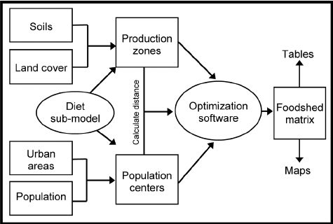

**Figure 1: Data Flow Diagram**

# CODE SKELETON

import numpy as np

import matplotlib.pyplot as plt

def exponential_growth(initial_population, growth_rate, years):

population = [initial_population * (1 + growth_rate) ** year for year in range(years)]

return population

def logistic_growth(initial_population, growth_rate, carrying_capacity, years):

population = [carrying_capacity / (1 + ((carrying_capacity - initial_population) / initial_population) * np.exp(-growth_rate * year)) for year in range(years)]

return population

initial_population = 7.9e9

growth_rate = 0.011

carrying_capacity = 10e9

years = 50

exp_population = exponential_growth(initial_population, growth_rate, years)

log_population = logistic_growth(initial_population, growth_rate, carrying_capacity, years)

years_range = np.arange(years)

plt.plot(years_range, exp_population, label='Exponential Growth')

plt.plot(years_range, log_population, label='Logistic Growth')

plt.title('World Population Growth')

plt.xlabel('Years')

plt.ylabel('Population')

plt.legend()

plt.show()

**RESULT ANALYSIS:**

**Current World Population**: As of the latest available data, the world population is estimated to be around 7.9 to 8 billion people. It's important to note that this number is constantly changing due to births, deaths, and migrations.

**Population Growth Rate**: The global population growth rate has been gradually declining over the past few decades. While the population continues to grow, the rate of growth77 has slowed down. This is mainly due to factors such as declining fertility rates, increased access to family planning services, and improvements in healthcare leading to decreased mortality rates.

**Environmental Impact**: The size and growth of the world population have significant implications for the environment, including resource consumption, pollution, and biodiversity loss. Sustainable population management strategies are essential for addressing environmental challenges such as climate change and habitat destruction.

**OUTPUT SAMPLES**

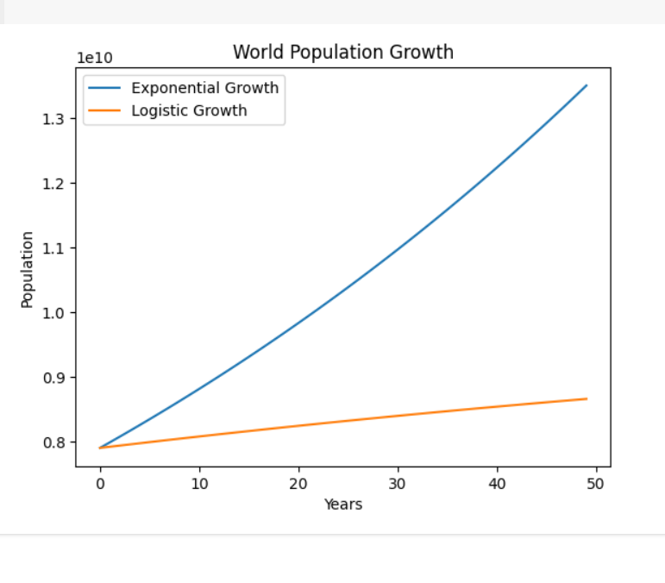

**REFERENCES**

* Abbasi-Shavazi MJ, McDonald P, Chavoshi M. Dordrecht: Springer; 2009. The Fertility Transition in Iran. Revolution and Reproduction. [[Google Scholar](https://scholar.google.com/scholar?q=Abbasi-Shavazi+MJ+McDonald+P+Chavoshi+M+The+Fertility+Transition+in+Iran.+Revolution+and+Reproduction+2009+Dordrecht+Springer+)]
* Blanc AK. The effect of power in sexual relationships on sexual and reproductive health: an examination of the evidence. *Stud Fam Plan.* 2001;32:189–213. [[PubMed](https://pubmed.ncbi.nlm.nih.gov/11677692)] [[Google Scholar](https://scholar.google.com/scholar_lookup?journal=Stud+Fam+Plan&title=The+effect+of+power+in+sexual+relationships+on+sexual+and+reproductive+health:+an+examination+of+the+evidence&author=AK+Blanc&volume=32&publication_year=2001&pages=189-213&)]
* Chakravarty S, Chikkatur A, de Coninck H, et al. Sharing global CO2 emission reductions among one billion high emitters. *Proc Natl Acad Sci USA.* 2009;106:11884–11888. [[PMC free article](https://www.ncbi.nlm.nih.gov/pmc/articles/PMC2706272/)] [[PubMed](https://pubmed.ncbi.nlm.nih.gov/19581586)] [[Google Scholar](https://scholar.google.com/scholar_lookup?journal=Proc+Natl+Acad+Sci+USA&title=Sharing+global+CO2+emission+reductions+among+one+billion+high+emitters&author=S+Chakravarty&author=A+Chikkatur&author=H+de+Coninck&volume=106&publication_year=2009&pages=11884-11888&pmid=19581586&)]
* Cohen JE. Make secondary education universal. *Nature.* 2008;456:572–573. [[PubMed](https://pubmed.ncbi.nlm.nih.gov/19052604)] [[Google Scholar](https://scholar.google.com/scholar_lookup?journal=Nature&title=Make+secondary+education+universa&author=JE+Cohen&volume=456&publication_year=2008&pages=572-573&pmid=19052604&)]
* De Haas H. International migration, remittances and development: myths and facts. *Third World Quarterly.* 2007;26:1269–1284. [[Google Scholar](https://scholar.google.com/scholar_lookup?journal=Third+World+Quarterly&title=International+migration,+remittances+and+development:+myths+and+facts&author=H+De+Haas&volume=26&publication_year=2007&pages=1269-1284&)]
* Do M, Kurimoto N. Women’s Empowerment and Choice of Contraceptive Methods in Selected African Countries. *Int Perspect Sex Reprod Health.* 2012;38:23–33. [[PubMed](https://pubmed.ncbi.nlm.nih.gov/22481146)] [[Google Scholar](https://scholar.google.com/scholar_lookup?journal=Int+Perspect+Sex+Reprod+Health&title=Women%E2%80%99s+Empowerment+and+Choice+of+Contraceptive+Methods+in+Selected+African+Countries&author=M+Do&author=N+Kurimoto&volume=38&publication_year=2012&pages=23-33&pmid=22481146&)]
* Espenshade TJ, Olgiati AS, Levin S. On unstable and stable population momentum. *Demography.* 2011;48:1581–1599. [[PMC free article](https://www.ncbi.nlm.nih.gov/pmc/articles/PMC3951110/)] [[PubMed](https://pubmed.ncbi.nlm.nih.gov/21948106)] [[Google Scholar](https://scholar.google.com/scholar_lookup?journal=Demography&title=On+nonstable+and+stable+population+momentum&author=TJ+Espenshade&author=AS+Olgiati&author=S+Levin&volume=48&publication_year=2011&pages=1581-1599&pmid=21948106&)]
* Ewing B, Moore D, Goldfinger S, Oursler A, et al. Oakland, CA: Global Footprint Network; Ecological Footprint Atlas 2010. [[Google Scholar](https://scholar.google.com/scholar?q=Ewing+B+Moore+D+Goldfinger+S+Oursler+A+Ecological+Footprint+Atlas+2010+Oakland,+CA+Global+Footprint+Network+)]
* Habbema JDF, Collins J, Leridon H, et al. Towards less confusing terminology in reproductive medicine: a proposal. *Hum Reprod.* 2004;19:1497–1501. [[PubMed](https://pubmed.ncbi.nlm.nih.gov/15220305)] [[Google Scholar](https://scholar.google.com/scholar_lookup?journal=Hum+Reprod&title=Towards+less+confusing+terminology+in+reproductive+medicine:+a+proposal&author=JDF+Habbema&author=J+Collins&author=H+Leridon&volume=19&publication_year=2004&pages=1497-1501&pmid=15220305&)]
* Hoekstra AY, Chapagain AK. Water footprints of nations: Water use by people as a function of their consumption pattern. *Water Resources Management.* 2007;21:35–48. [[Google Scholar](https://scholar.google.com/scholar_lookup?journal=Water+Resources+Management&title=Water+footprints+of+nations:+Water+use+by+people+as+a+function+of+their+consumption+pattern&author=AY+Hoekstra&author=AK+Chapagain&volume=21&publication_year=2007&pages=35-48&)]